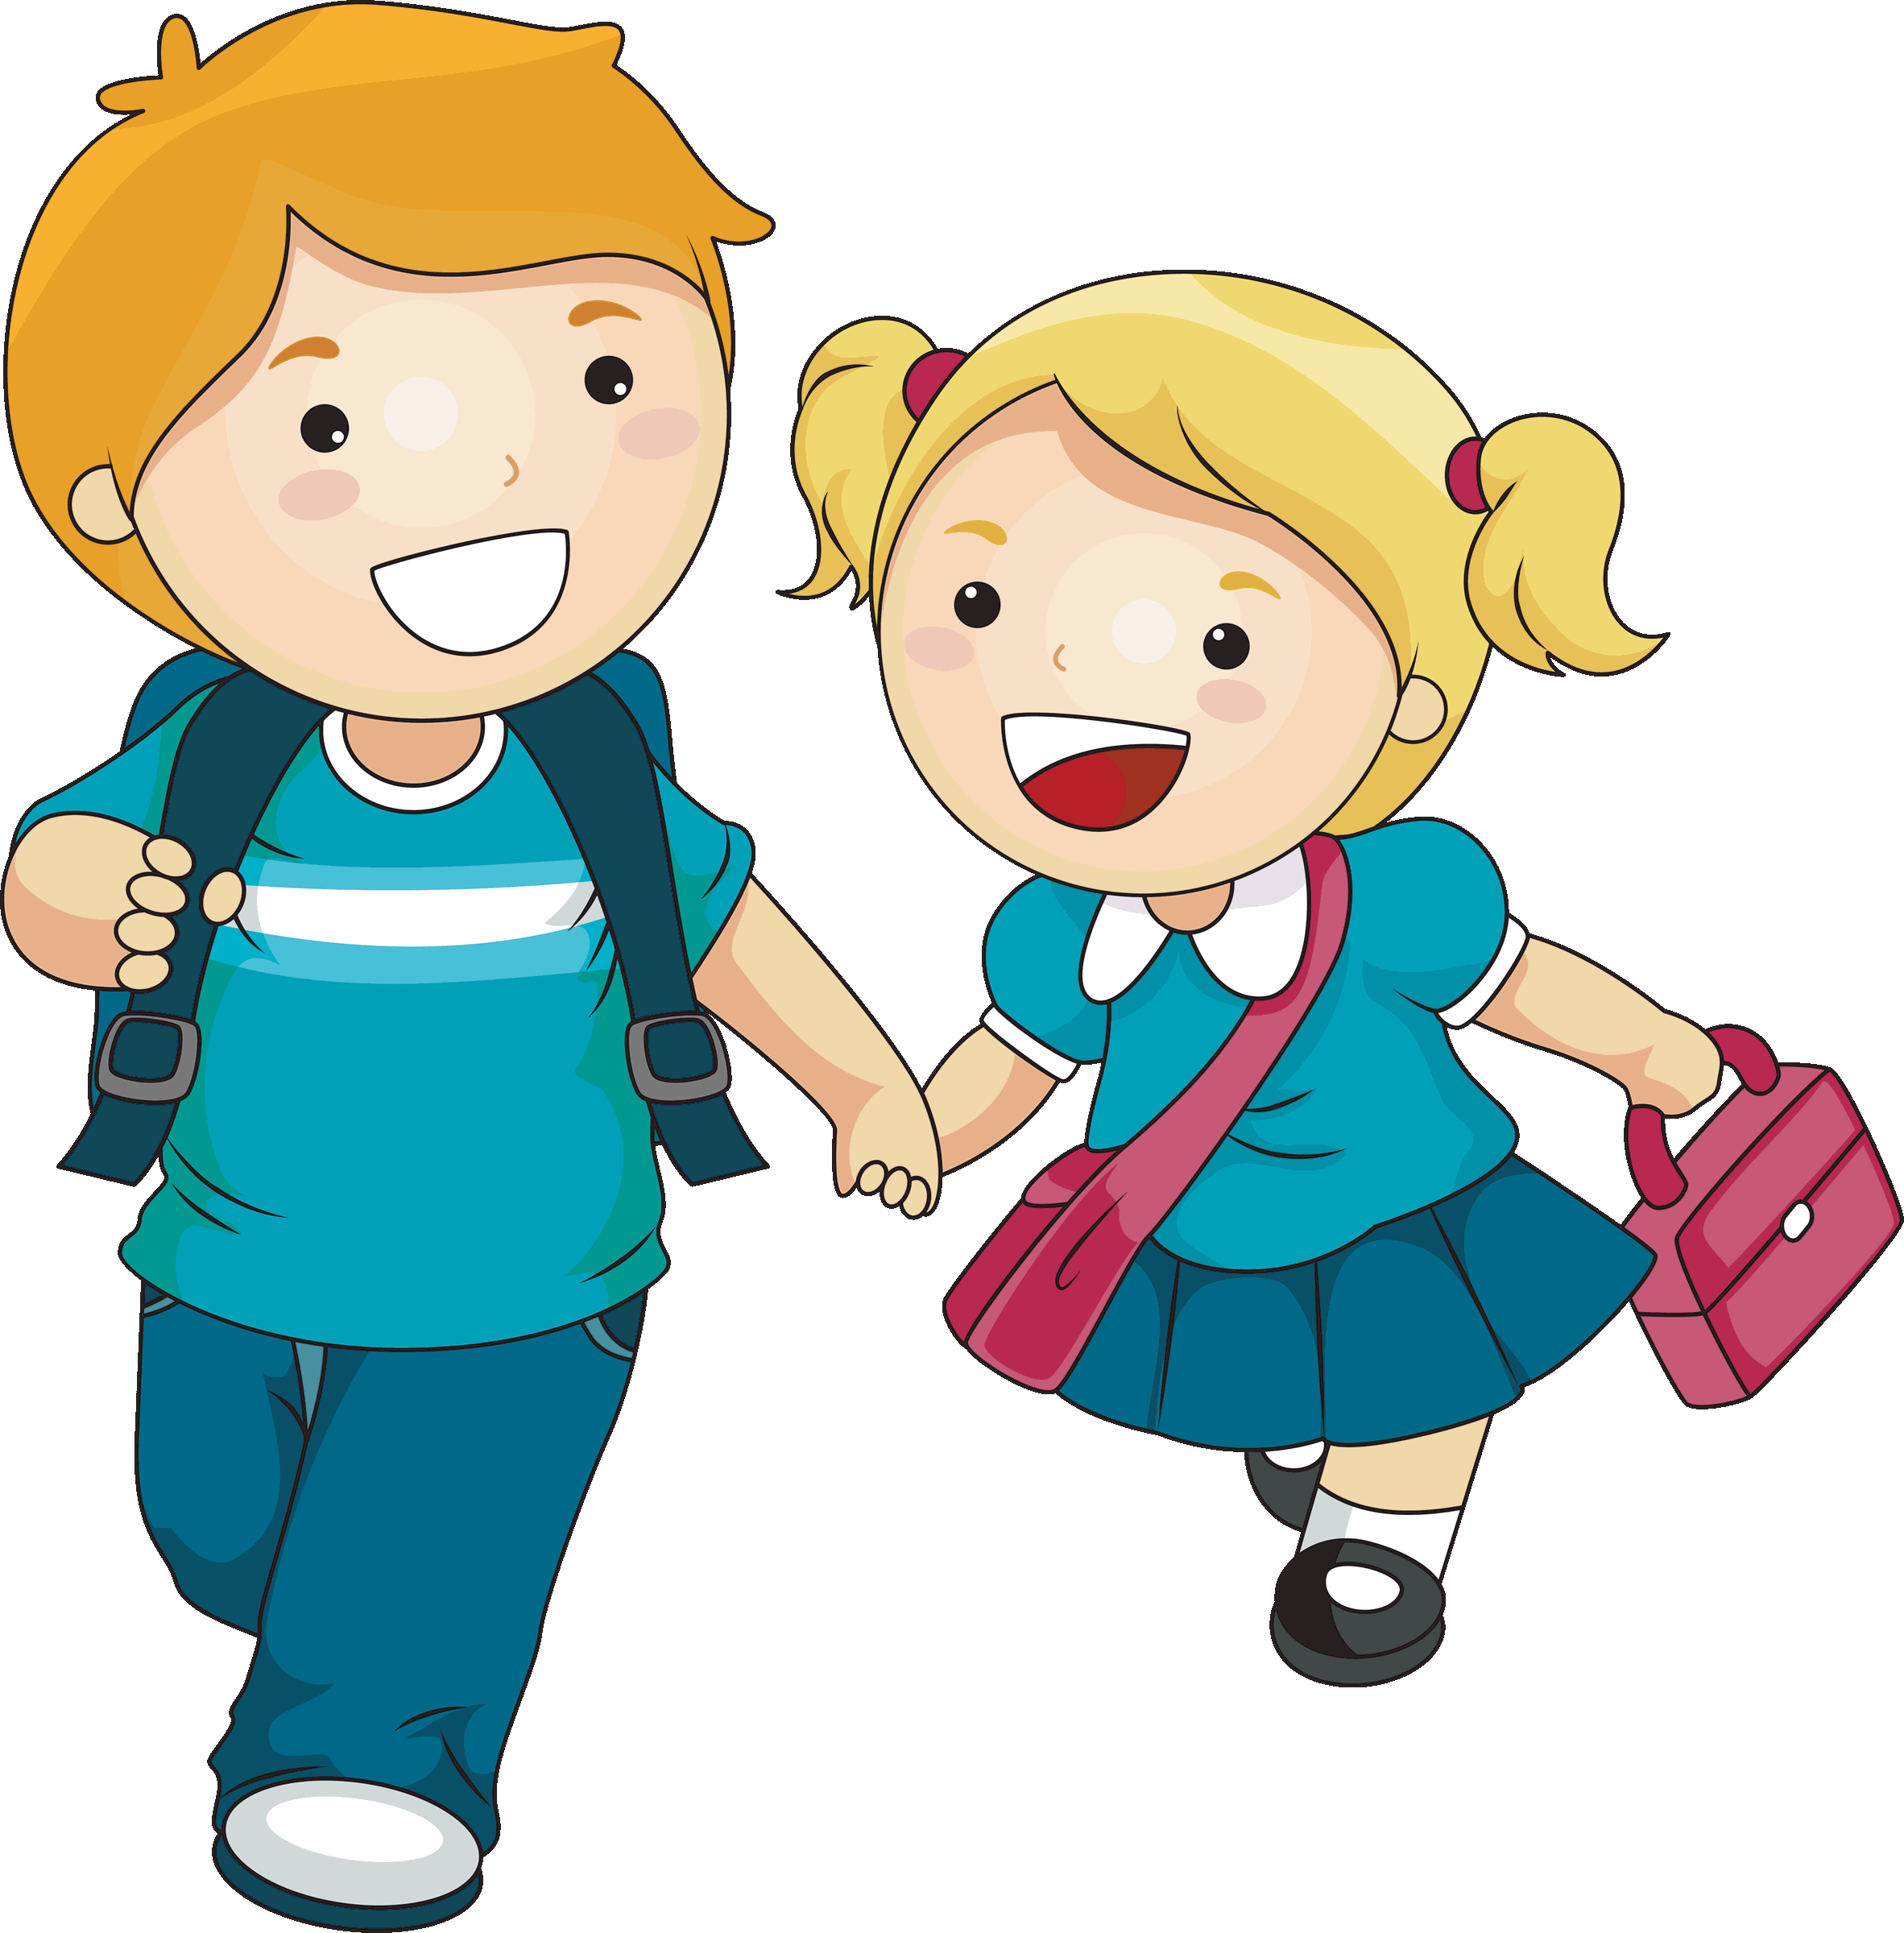
Personal, Social and emotional Development
Encourage me to make new friends and talk to others. I should be able to share and take turns (I may sometimes need a little support to do this.)
Provide opportunities to play games where there is a winner and a loser (I should understand that I cannot always win!)
Encourage me to talk about my feelings. How do I feel in different situations? Why? How do others feel? How can we tell if someone is happy/sad/excited/lonely/worried/angry? I should be able to talk about how I feel and understand how others might be feeling.
Give me lots of opportunities to make my own decisions. Would I prefer cereal or toast? Which present would be best for my friend? What am I most looking forward to about starting school?
I need to be able to think independently and make some simple decisions.
Encourage skills which support my personal and social development- collaboration/team work, resilience/not giving up, having courage/being brave enough to try new things.
If I like to ask “why” ask me “well why do you think?” This gives me the chance to think for myself.

Physical Development
Play games with me like football, throwing and catching.
Encourage me to play with play dough (it gives great exercise for my fingers and builds up the muscles required for writing!) Threading things is also great for this!
Let me practise using scissors to cut! Show me how to hold scissors correctly.
Encourage me to hold a pencil correctly. I may not be able to write words yet, but I should be able to make marks, draw and copy letters. Encourage correct letter formation from the start. Teach your child to write in lower case letters (not capital letters- this is particularly important when writing your name. A capital letter should be used for the first letter only.)
When starting school, I should be able to undress and dress myself independently. I need to be able to turn my clothes the right way around if they are inside out- I will need to practise doing this at home. Allow your child to put on/take off their own clothes, coat, tights, socks, shoes, bag etc.
Most of the time, I should be able to get to the toilet in time. I must be able to wipe myself fully independently (practise doing this using toilet paper rather than moist wipes.)
I will need to be able to use a knife and fork to try cutting my own food. Encourage me to use a knife and fork (rather than spoon) to eat my meals. I should have some understanding of how I can be healthy.

Communication and Language
Model and encourage me to use good listening skills (eye contact, no interrupting, taking turns in conversation, no distractions.)
Encourage me to listen and then respond. Speak clearly to me and support me in doing the same back.
I should be able to maintain attention for a short time and sit quietly when asked.
Ask me questions (how/why/who/when/what) to help develop my understanding. I should be able to answer some questions.
Encourage and expect me to follow instructions (as soon as I am asked.) Classroom instructions often contain several parts. Play games like “Simon Says” – introduce several parts to the instruction (e.g. Simon says touch your nose then clap your hands then put your hands on your head.) Start with one instruction and build up to 2 or 3. I should be able to follow and understand 2 part instructions when I start school (e.g. Put your coat on and then find your shoes.)
Read me stories and encourage me to join in with my favourite bits. Ask me questions about the story. I should be able to answer some questions and talk about the characters.
Encourage me to order and sequence events. Listen to a story- then retell it to mummy/daddy/granny etc. Look at photos from days out/holidays etc and ask your child to organise them and retell what happened. Model using words such as: first, next, last, before, after, finally.

